06
Web Crawler
Scraper Manual
David Tee

Contents
Scraper Overview 3
Tool Bar 3
View Node Data Window 4
Result Data Window 4
Result Data Window w/ Multiple Tables 5
Tag Tree 5
Tag Properties 6
Sample [Scrape] Projects 7
Basic Tag 7
Basic Tag 2 7
Regex Tag 7
Regex Data 8
Multi Tag 8
Look Behind 8
Optional Tag 9
Max Data Length 10
Sample Project: BackCountry.com 11
Sample Crawl Project: Lyrics007.com 11

Scraper Overview
The scraper allows the user to configure the tag library to extract/parse the data from a given string.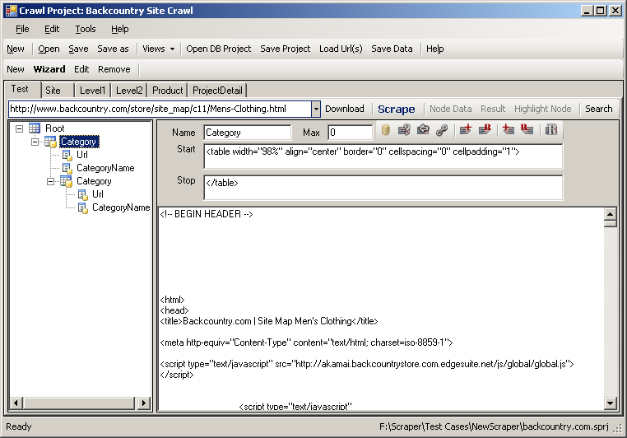
Figure 1: Scraper

Tool Bar
Tool bar contains various buttons to help user test the tag library.
Toolbar Item | Description
URL List Combo box | User can enter in URLS to download. User can also quickly switch between the downloaded URLSs.
Download | Download the context of the URLs to the sample text box .
Scrape | Scrape the current context in the sample text box.
Node Data | View the scraped data of the selected tag tree. This will toggle the “View Node Data” Window. This button is only available after the Scrape is successful.
Result | View the resulting dataset of the scrape. This is the dataset scraped from the current tag tree. This button is only available after the Scrape is successful, and the scrape generate at least one data table.
Highlight Node | Highlight the text scraped.
Search | Search the pattern/rules defined in the tag properties

View Node Data Window
This window allows the user to view the resulting data from the current node selected in the Tag Tree
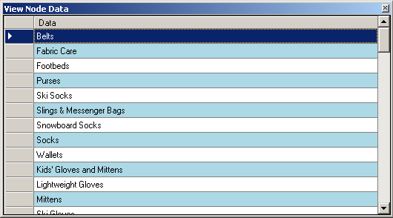
Figure 2: View Node Data Window

Result Data Window
This window allows the user to view the resulting dataset from the scrape. (The resulting dataset is only available if the tag library generates at least one data table.) In this window, you can select the table to view (if multiple tables are generated) , and the child table if there’s any.
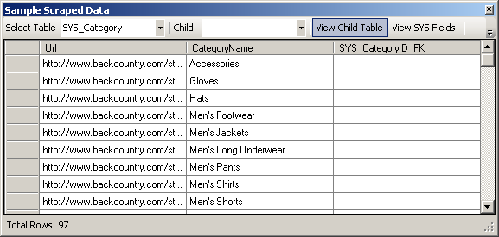
Figure 3: Result Data

Result Data Window w/ Multiple Tables
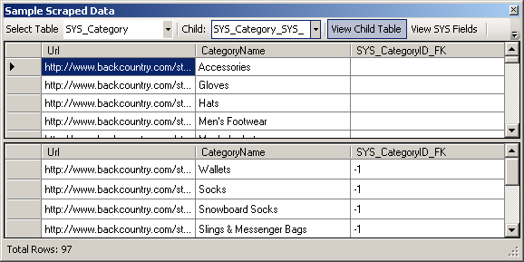
Figure 4: Result Data w/ Multiple Tables
In the figure above, you will notice that the view contains two tables. The table on top contains the first table, and the table on the bottom is the child table (a table that have foreign key constraint that that references another table). Changing the row selected in the top table will change the content of the child table.
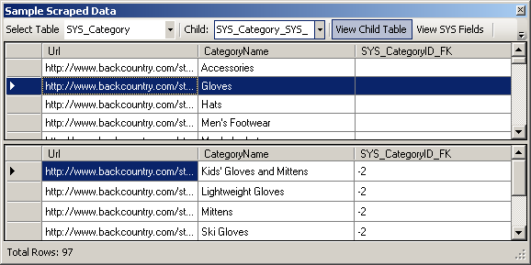
Figure 5: Result Data view w/ different row selected

Tag Tree
Tag tree allows the tree view of the tags in the tag library. Tag Tree represents the tree of tags. This could be compared to the DOM tree. User can move drag and drop the tag node into another node like can in window’s file explorer. User can also move the the tag node up or down to position the scrape patterns.
Icon | Item | Description
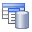 | Table and Field | The tag field will be saved to database, but it also serves as a temporary field for extraction data.
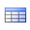 | Temporary Table | Tables that will be saved to database, this is probably an intermediate tag node to narrow down the desired data.
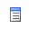 | Temporary Field | Field that will not be saved to database, this is to filter out some of the fields that must be configured in order for the scraper to scrape other fields that would be saved to database.
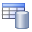 | Table | Table that will be saved to database.
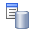 | Field | The field being saved to database.

Tag Properties
The tag contains information about how the desired data be extracted. The example project included with the program will further explain the meaning of the properties listed.
Icon | Property | Description
 | Name Text box | The name of the tag, this must be unique with in a tag group.
 | Max Text box | The maximum length of the characters of the data to be extracted.
 | Save Data | Save the data as data field in the database
 | Optional | Optional Tag
 | Reverse Search | The search pattern will be searched in reverse
 | URLs Data | The data scraped is URLs link. The crawler will fix the relative URLs and make the absolute URLs based on the current URLs that’s being scraped.
 | Append Start Tag | Append the start tag to the data
 | Regular Expression Start Tag | The start tag pattern is a regular expression. , the scraper will treat it as such.
 | Append End Tag | Append the end tag to the data.
 | Regular Expression End Tag | The end tag pattern is a regular expression, the scraper will treat it as such.
 | Single Regular Expression | When checked, user may enter one regular expression pattern to search (There’s no Start and End Tag text box)
 | Start [Tag pattern] Text box | Start tag is similar to xml’s elements. <xml>data</xml>. To extract the data, the start tag in this case on the <xml>
 | End [Tag pattern] Text box | The end text that the desired data to be extracted is bound to. This can be described using regular expression or just literal text.

Sample [Scrape] Projects
The crawler is shipped with a sample crawl solution that contains sample Scraper Configurations. Open “example.sproj” for the sample data. The sample projects in with crawl solution is described in details below.

Basic Tag
This Scrape Project demonstrates the basic tag library configuration possible. On the tag library tree, there’s a root Node, named “Root”. It has one child node named “Name”. Because the child is a leaf node, the icon showed is a field icon. In database sense, “Root” will be the table and “Name” would be one of the field of the table.
If the Save Data was enabled, then the field would be saved into database, and the icon for the Node will change, and a database table would be generated. Enable the save property of the Name tag and run the scrape again, you will see that the Result button is enabled. You can view the resulting data table of the current scrape project (the window below).
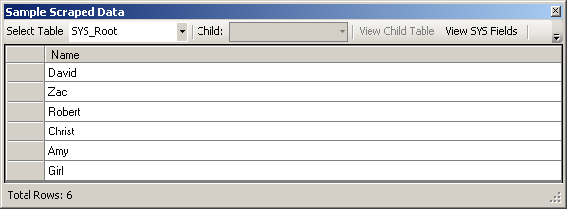
Figure 6: Result Data
In this project, the goal is to scrape the name from the given text. Name is bounded between <td> and </td> tags. So, in the Start text box and stop text of the name, I specified <td> as the start pattern, and </td> as the end pattern. The scraper will look for the following regular expression pattern: <td>(any characters)</td>.

Basic Tag 2
This is the same process as Basic Tag, but this time, there’s no start tag, but the end tag is one space. This demonstrates that a tag only requires either a start tag or end tag. If nothing is specified in the start or end tag text box, then the scraper would return the text.

Regex Tag
In this Scrape project, the start tag is selected as a regular expression pattern, and the pattern specified in the start [tag pattern] text box is an regular expression that will match: < follow by any one digit, followed by td>.

Regex Data
In this scrape project, only one regular expression pattern is defined. The scraper will search for the pattern (which looks for valid email address) and return the results.

Multi Tag
This scrape project demonstrates the multiple tag support in the tag library. The scraper will search for the pattern specified by multiple tags.

Look Behind
This scrape project demonstrates the look behind property of the a tag. Normally, the scraper will match the pattern going from left to right, but if look behind property of the tag is selected, the pattern is matched going from right to left.
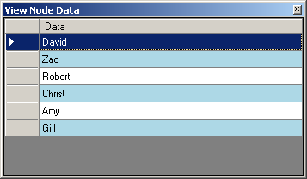
Figure 7: Look behind enabled
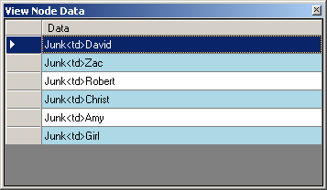
Figure 8: Look behind Disabled
When the look behind is disabled, the scraper will look for the following pattern: <td>(any characters)<\td>. If the look behind is enabled, the scraper will look for the same pattern, but run another pattern match on the result that would match the result going form right to left.

Optional Tag
This scrape project demonstrates the optional tag property. In the given sample data, the given string has inconsistent pattern. Named is bounded between <td> and <br>, Gender is bounded between <br and <br>, and the height is bounded between <td> and <br>. But in case of Chris, he is missing the Gender field, and we want the scraper to get Chris’s information. The Optional Tag property of allows the scraper to scrape Chris even if one of the tags is missing. Try taking away the optional property, the result data would be different.
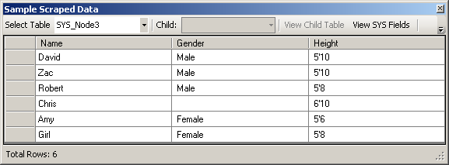
Figure 9: With Optional Tag Enabled
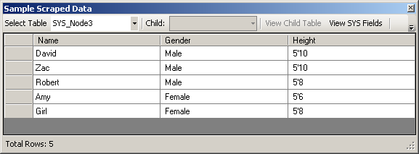
Figure 10: With Optional Tag Disabled
You will also notice that I placed a tag node (padded node) between the root and the fields that I want to scrape. If you look at the data scraped for the node, you will see the following:
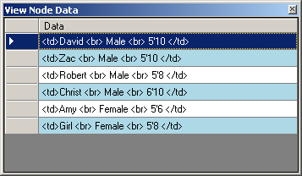
Figure 11: Content of padded Node
If I take away the padded node, the data scraped will be the desired data. The result is showed in the figure below. This is because the scraper searches for the pattern given by the child nodes.
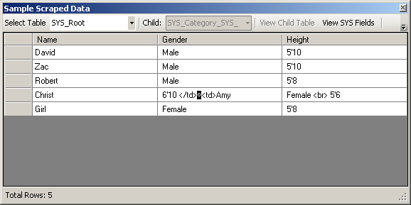
Figure 12: Result without the padded Tag Node

Max Data Length
The max length property of a tag node allow the data scraped from the tag be bounded by character length. In this project, max size allowed is 4, thus the data scraped is the names that are less than 4 character length. David, Robert and Chris are not scraped.
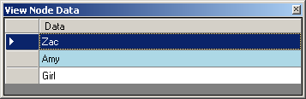

URLs
The concept of URLs node is explored in this project. A tag node that has URLs property enabled is a URLs node. The scraper will convert the relative URLs to absolute URLs after the scrape process. (This node allows the crawler to figure out the next URLs to download and scrape)
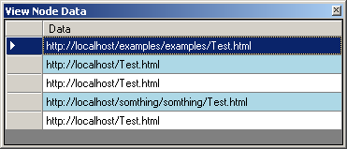
Figure 13: Result with URLs Enabled

